Nuisance task force

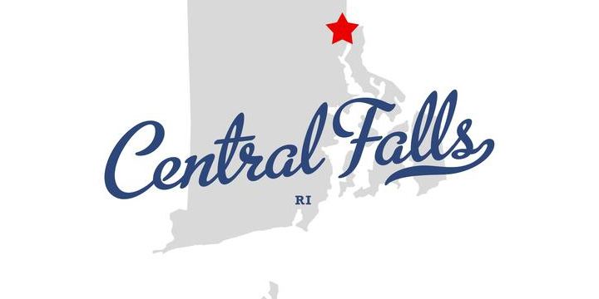

How to avoid foreclosure:

* Do not ignore letters from your lender/loan servicer. If you are at risk of foreclosure, you should contact your lender/loan servicer immediately.
* Remain in your home. You may not qualify for assistance if you abandon your property.
* Contact a HUD Housing Counselor. The Department of Housing and Urban Development, through its HUD Housing Counselors, will assist at-risk homeowners, and are often successful in keeping individuals in their homes.
* Be aware of scams and predatory lenders. Lease-back or rent-to-buy programs, fake government modification programs, and refinance fraud do exist. These lending practices will increase an individual’s chances of losing their home.
* Enroll in a class for first-time homebuyers or money management to learn exactly how to prevent foreclosure: [www.MoneyManagement.org](http://www.MoneyManagement.org) or [loans.rhodeislandhousing.org/Education_Center/](http://loans.rhodeislandhousing.org/Education_Center/)

recommended steps to take:

* Contact HUD and speak with an independent counselor: 800-569-4287 (TTY 800-877-8339) [www.hud.gov](http://www.hud.gov)
* Contact State Foreclosure Prevention Programs. Rhode Island Housing: (401) 457-1130
* Explore your options through Federal Foreclosure Assistance Programs. The Federal Government has designed programs to help homeowners refinance mortgages and avoid foreclosure. For more information on refinancing, contact HUD’s interactive voice response system at 1-800-569-4287, or go directly to the FHA website.

additional resources:

* Blackstone Valley Community Action Program 401-723-4520 www.bvcap.org
* Community Works RI 401-273-2330 [www.communityworksri.org](http://www.communityworksri.org)
* ONE Neighborhood Builders 401-351-8719 <http://www.oneneighborhoodbuilders.org/>
* Rhode Island Housing & Mortgage Finance Corporation 401-457-1000 www.rhodeislandhousing.org
* West Elmwood Housing Development Corporation 401-453-3220 [www.westelmwood.org](http://www.westelmwood.org)
* Money Management International 866-232-9080 [www.moneymanagement.org](http://www.moneymanagement.org)
* NeighborWorks Blackstone River Valley 401-762-0074 [www.NeighborWorksBRV.org](http://www.NeighborWorksBRV.org)

Contact us today!

For advice and assistance on how to avoid foreclosure, as well as what to do if you’re already at risk, contact us today:

**Robert Weber, Esq. Executive Director of the Central Falls Nuisance Task Force (401) 616-2408** [**rweber@centralfallsri.us**](mailto:rweber@centralfallsri.us)